Attachment A : Nitrous Oxide Emissions
Southern Region sites.
Inverleigh Cum. N₂O Flux Wheat 2014

Nitrous Oxide Emissions, Horsham

Nitrous Oxide Emissions, Esperance and Swan Hill

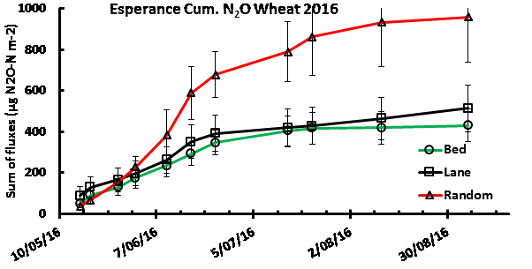

Northern Region Sites

