rD&E Trial Protocol Template

2023/24
Trial Protocol

NGN - Investigating late winter and early spring cereal cropping opportunities for grain growers following autumn waterlogging - South-Western Australia

Project code: | SCF2306-005SAX
Prepared by: | Elizabeth von Perger
CEO@scfarmers.org.au

Stirlings to Coast Farmers

Date submitted to GRDC: | 14 July 2023

Once completed this template is to be submitted in Word format via the ‘Grains Investment Portal’ - https://access.grdc.com.au/.

PROJECT SUMMARY
This project will run for a second year, examining the viability and productivity of late winter and early spring sown cereal varieties in the southern region of Western Australia. The trial will assess which crop types (wheat/barley), varieties and nutrition strategies are most suitable to late seeding conditions in years that waterlogging prevents autumn seeding. This project was developed in response to waterlogging events in the Albany Port Zone (APZ) and Esperance Port Zone (EPZ) in 2021, 2022 and again after June rain in 2023. Coastal regions of the WA grain belt are prone to large areas of crops remaining unplanted well into July and August due to waterlogging leaving paddocks untrafficable.
The project was farmer-driven and put forward by growers and consultants within the APZ and EPZ. They wanted to know how late cereal crops could be sown, whilst still being profitable, what cereal crops types/varieties would do better, and how to manage nutrition of these crops when sowing so late in the growing season. All very valid questions. At the time there was no publicly available data on late sowing wheat and barley for growers to reference to inform their decision-making. Given waterlogging is a relatively common occurrence in some parts of the APZ and the EPZ, it is imperative that farmers have resources to lean on in order to mitigate losses and maximise the productivity the years they are impacted. This project will aim to fill this knowledge gap, by providing locally relevant data directly to local growers and consultants. The data generated will be another tool to manage the increased climate variability.
TRIAL OBJECTIVES
The objective of the four small plot trials is to provide statistically sound data that will inform farmer and consultant decision making in years of early waterlogging, where they are considering late sown cereals as an option. The trials will be professionally implemented and managed by industry best practice standards to ensure the data is reliable. The implementation of four trial sites also ensures the data generated is locally relevant to farmers right along the South Coast of WA.
GRDC Project Outcome:
By March 2024, All Western Region growers and advisers will have access to trial information on late winter to early spring sown cereals (wheat and barley) on the south coast of WA to assist in making educated decisions to sow at this time when waterlogging presents and cereal crops cannot be sown at the traditional time or for other reasons that may present for a later sowing opportunity such as weed issues or poor crop establishment.

METHOD
Stirlings to Coast Farmers and SEPWA will be responsible for the management of four separate trials on the South Coast of the Western Region. Two will be located in the APZ and managed by SCF (South Stirling & Gairdner) and two will be located in the EPZ and managed by SEPWA (Dalyup & Condingup). Experienced trial providers will be sub-contracted to seed and manage the trials, and suitably qualified staff will record trial measurements and take samples (where the trial provider is not contracted to undertake).
The trial sites will be established in late-July when the first time of sowing treatments will be sown. The two subsequent time of sowing treatments will be sown approximately three weeks apart, after the first timing. The treatments will include three barley varieties and two wheat varieties, and where possible varieties will remain the same between trial sites and consistent with 2022 trials, for direct comparison. A main and a quick season variety will be included for each crop type (wheat and barley).
Measurements and sampling will be undertaken and conducted at timings as per the ‘Data Collection and Monitoring’ table (see below).
The sampling and monitoring program includes:
• Pre-seeding soil moisture content
• Plant establishment counts (plants/m2)
• In -season biomass sampling (dry matter kg/ha)
• In-season tissue testing
• Flowering date assessment
• Harvest yield (small-plot header)
• Grain quality
• Rainfall observations
• Weed, disease and pest observations
The statistical analysis will be conducted by Stirlings to Coast Farmers for all four small plot trial sites using the program JMP Pro. This use of this program will be discussed with AAGI prior to undertaking any analysis.
SCF will provide SEPWA and the trial providers with a template on which to enter data, for consistency.
TRIAL SITE DESIGN & TREATMENTS
SCF can confirm that the trials has been designed and randomised with input from AAGI. The design includes three times of sowing (late-July, mid-August and mid-September). Each time of sowing will include two wheat varieties (1 main season, 1 quick season) and three barley varieties (2 main season, 1 quick season) by two nitrogen strategies. The nitrogen strategies will be dictated by what has recently occurred in the paddock i.e., less upfront fertiliser if paddock is being re-sown. Each treatment will be replicated three times.
The AAGI approved designs for each of the four trial sites are shown in Figures 1 – 4.

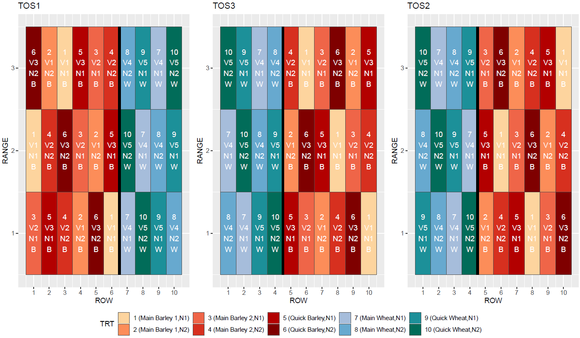
Figure 1: Late Sown Cereal Trial Design, Dalyup 2023.

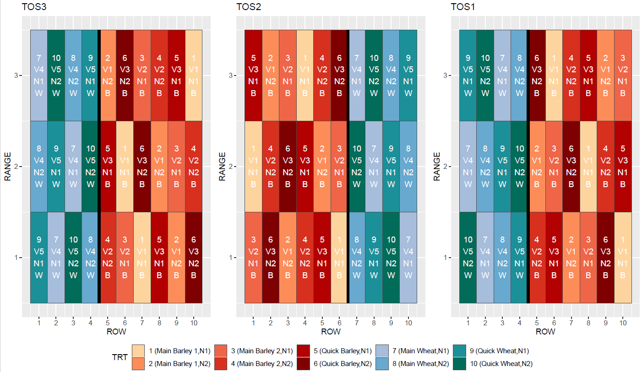
Figure 2: Late Sown Cereal Trial Design, Condingup 2023.
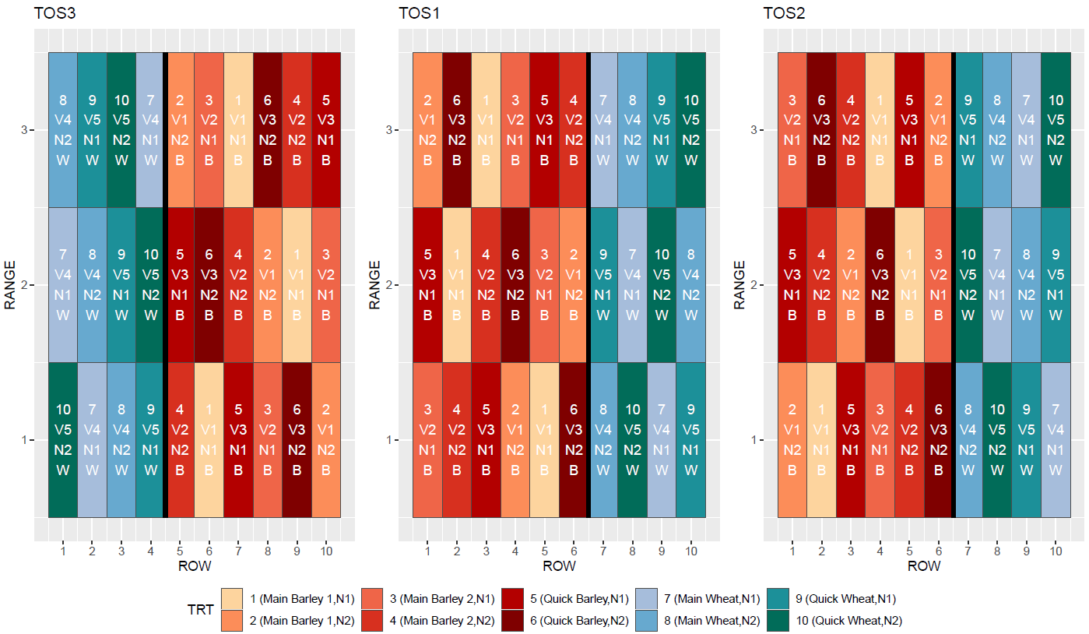
Figure 3: Late Sown Cereal Trial Design, South Stirling 2023.

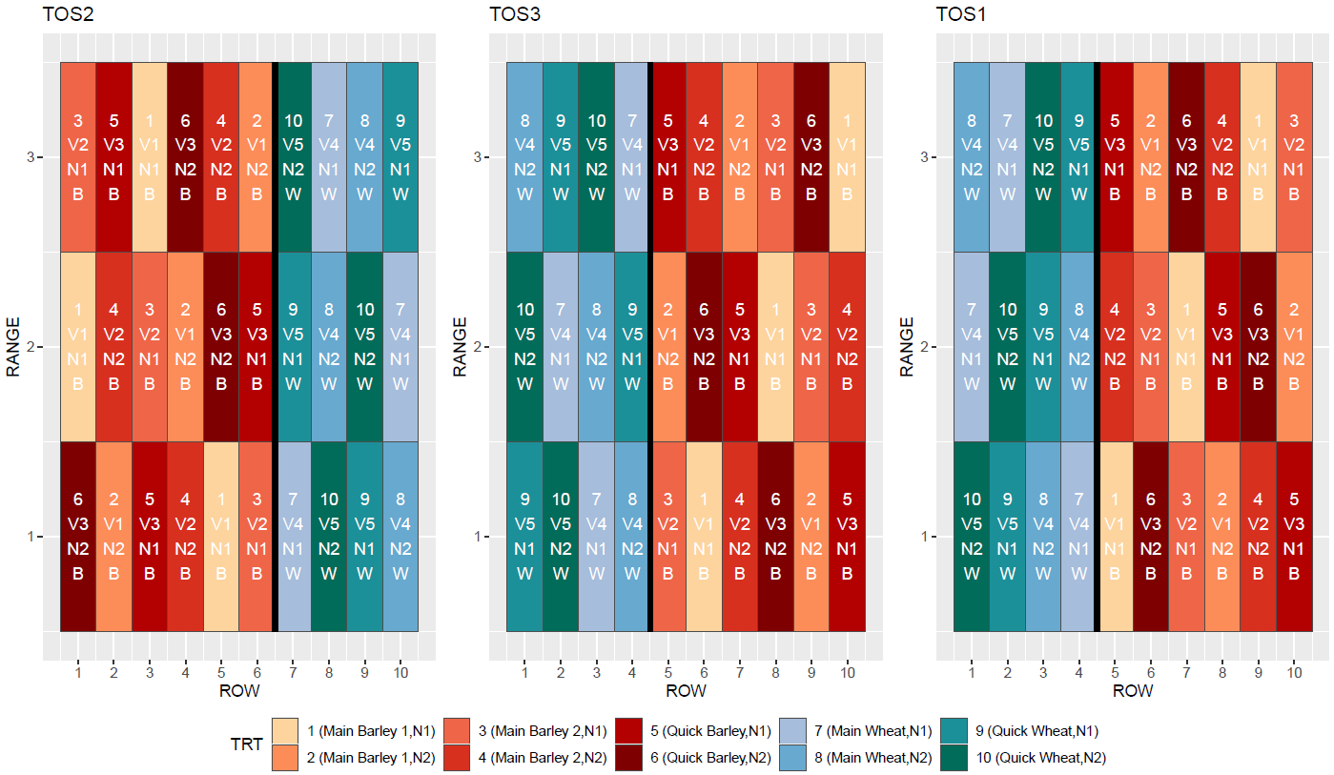
Figure 4: Late Sown Cereal Trial Design, Gairdner 2023.

DATA COLLECTION & MONITORING
Element | Method | Timing
Baseline soil classification | Complete analysis for soil within the plots, either through recent farmer held or publicly available soils data, or new soil tests. | Mid-July 2023
Volumetric water content | Soil sample to 60cm – soil water content will be determined in 10cm increments. Calculation: (Wet soil weight/dry soil weight) x bulk density. | Late-July - Sept 2023
Demonstration site establishment | Sites will be pegged out and blocked prior to the first TOS. | Late-July 2023
Plant establishment counts Z15-19 | Plant establishment counts will be taken by measuring 1m of two parallel seeding rows and converted to plants per m². Min of 3 per plot. | Aug - Oct 2023
Plant tissue sampling – stem elongation Z31-39. | Samples will be collected as per testing standards and sent to an accredited laboratory for standard nutrient analysis | Sept – Nov 2023
Plant Biomass – Z60-69 | This will be measured as dry matter (t/ha). 2 rows x 1m per plot. Representative 25 head sample dried at less than 107 °C - until no weight fluctuation. | Oct - Nov 2023
Flowering assessment – Approx. Z65 | At approx. Z65 record mid-flowering date, include photo, to accurately assess what period of flowering it is. | Oct - Nov 2023
Rainfall, weed, disease and pest observations | Observations for each will be recorded at the regular site visits and managed as per best practice. | Growing Season 2023.
Harvest yield & Grain Protein | Harvest yields internal scale on small plot harvester. Grain protein completed by Infratech. | Dec 2023/ Jan 2023

TRIAL LOCATION/S
Please include location details: Latitude and Longitude, nearest town, Grower contact details and soil types using the table below (please add additional rows as required):
 | Latitude (decimal degrees) | Longitude (decimal degrees)
Trial Site #1 | -34.33899 | 118.50030
Nearest Town | South Stirling
Grower Name & Contact Details | Tristan Stanich
Soil Types | Sandy Loam
Trial Site #2 | -34.380634 | 118.902167
Nearest Town | Gairdner
Grower Name & Contact Details | Jarrod King
Soil Types | Sandy duplex
Trial Site #3 | -33.745971 |  | 121.536604
Nearest Town | Dalyup
Grower Name & Contact Details | Rohan Marold
Soil Types | Grey Deep Sandy Duplex
Trial Site #4 | -33.743242 |  | 122.959458
Nearest Town | Condingup
Grower Name & Contact Details | Con Murphy
Soil Types | Sandy Gravel over Clay

STATISTICAL ANALYSIS AND/OR MODELLING
A basic statistical analysis will be undertaken that compares the individual treatments on the following measurements.
- Plant establishment
- Plant biomass
- Plant tissue N
- Harvest yield
- Grain Protein
The analysis will be conducted using statistical software ‘JMP pro’ and SCF can confirm AAGI have been made aware of SCF’s intended use of this program. Before results are analysed, SCF will meet with AAGI statisticians to ensure they agree with the statistical analysis methods SCF propose to conduct.
REFERENCES & USEFUL LINKS
N/A

