Annual Results Report Template

2020
Annual Results Report

Incorporating Lime to depth on duplex wheatbelt soils

Project code: | 9176014 GRDC
Prepared by: | Amy Bowden
agrec@faceygroup.org.au

Facey Group

Emily Davey
admin@faceygroup.org.au

Date submitted to GRDC: | 13th April 2021

REPORT SENSITIVITY
Does the report have any of the following sensitivities?
Intended for journal publication NO
Results are incomplete NO
Commercial/IP concerns NO
Embargo date NO

KEY MESSAGES
- Lime application rate had the greatest influence on soil pH in the year of application.
- The highest lime application of 6 t/ha in combination with spading resulted in the greatest increase in pH across the trial, although at depths of 20-30cm and 30-40cm, 2t/ha, 4t/ha and 6t/ha of lime sand produced similar increases in pH.
- Higher rates of lime application rate did not increase germination, biomass or grain yield of the cereal crops trialed in the experiment.
- Deep ripping, followed closely by spading, increased grain yield compared to top-dressing in 2020.

SUMMARY
The loss of productivity due to soil acidity is a major problem faced by growers in the Western Australian Wheatbelt. The aim of this trial is to quantify the value of lime applications by different incorporation methods and at different rates. Five pH treatments were applied on the 14th March 2018 and were replicated 3 times; with lime rates of 0, 2, 4 and 6 t/ha and elemental sulphur conservatively applied at 70 kg/ha (Figure 1). The elemental sulphur was applied to increase the acidification of the soil and more rapidly demonstrate the losses that can occur due to acidification. Application of the pH treatments was by deep ripping, spading or top dressing.
Multiple seasons of this trial indicate that there have been noticeable changes in the pH levels under different lime application rates and incorporation methods. A statistical analysis conducted by SAGI West indicate that the effect of the pH treatments incorporated in early 2018 should weaken with time. The best incorporation technique for increasing pH was spading for all depths below 10cm. Although the highest application of lime (6t/Ha) produced the best results, at depths between 20-30cm and 30-40cm, all treatments except for the control (0t/ha) performed nearly equally well. From 2018 to 2020 an upward trend (increasing soil pH) was observed at the depths 20-30cm and 30-40cm, for all soil incorporation and pH treatments. However, the eﬀect on a year by year basis for the top and subsoil (0-10cm and 10-20cm) from the soil incorporation and pH treatments did not show a definable trend, with the pH in 2020 being slightly lower or higher than the pH in 2018.
The 2020 trial found that increasing lime application rate did not increase crop emergence, NDVI or grain yield. Incorporation method was found to impact on grain yield however, with deep ripping, closely followed by spading, increasing yield compared to the standard grower practice of top-dressing.

BACKGROUND
The loss of productivity due to soil acidity is a major problem faced by growers in the Western Australian Wheatbelt. Past liming trials have aimed to reduce the impact of acidification in deep sand plain soils. Concerns have been raised on how growers with acidic duplex soils have been managing their lime strategies.
Currently growers are varying the timing and application rates of lime with some applying a constant amount annually, others applying a blanket amount on certain paddocks every few years and some applying varying rates as required depending on soil type and pH. The majority of local farmers practice minimum till seeding and have previously only used top dressing for lime application. This trial will demonstrate to growers how using various tillage methods may provide better returns on lime application investment due to lime incorporation deeper into the soil profile, and subsequently the improvement of soil composition and plant water/nutrient uptake over time.

OBJECTIVES
The aim of this trial is to quantify the value of lime applications using different incorporation methods and compare the economic and agronomic returns of each. This trial also includes an application of a rapidly acidifying Elemental Sulphur to demonstrate how soils and crops will perform 10-years into the future if no action is taken to maintain pH levels. The trial also aims to analyse the interactions between each incorporation technique and its effects on ameliorating other crop constraints.

The objective is to give growers a greater understanding of different methods of lime incorporation and the most cost-effective practice locally and to extend on these findings with other research being conducted on varying soil types throughout the state, so that growers can make informed decisions for implementing their own liming strategy.
METHODS
The trial site was selected from soil cores taken on the 1st March 2018, as well as Dual EM and radiometric precision maps under advisement. The lime treatments were replicated 3 times; with lime rates of 0, 2, 4 and 6 t/ha, and elemental sulphur conservatively applied at 1 kg/plot (70 kg/ha) (Figure 1). The elemental sulphur was applied to increase the acidification of the soil and more rapidly demonstrate the losses that can occur due to acidification. The trial consists of producer scale plots 12.4m wide x 12m long, with lime applied on the 9th March 2018, using a Marshall multispreader. Tillage treatments were undertaken on the 14th March using a DepthCharger deep-ripper and an Imants Spader. In 2019, the trial was sown to Cutlass and Scepter wheat blend. Soil sampling to determine soil pH was conducted on 15th April 2020 by Precision Soiltech, with 1 sample per plot at increments of 10cm, to a depth of 40cm.
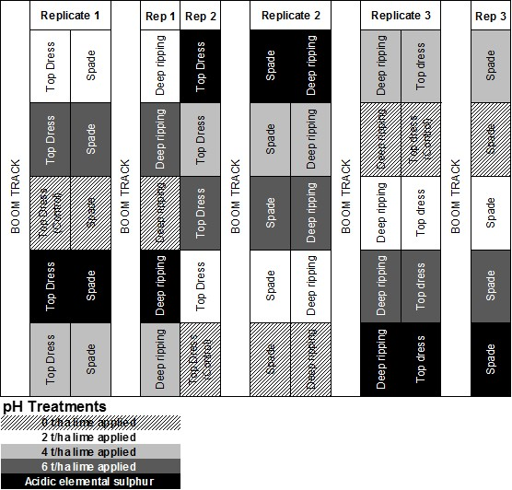
Figure 1: Trial Layout

The 2020 trial site was sown on the 20th May 2020 to Spartacus barley with no further treatments undertaken on those applied in 2018. Plant germination counts were completed on the 9th June 2020, at growth stage Z14. Three counts were taken per plot on randomized rows. Crop biomass was measured using NDVI testing at growth stage Z23 on the 30th June 2020.
Harvest data was collected by SLR using a small plot header, with two cuts per plot and a grain sample retained for grain quality analysis (1kg).

LOCATION
NOTE: Where field trials have been conducted please include location details: Latitude and Longitude, or nearest town, using the table below (please add additional rows as required):
 | Latitude (decimal degrees) | Longitude (decimal degrees)
Trial Site #1 | -32.785297° | 117.636856°
Nearest Town | Yealering

If the research results are applicable to a specific GRDC region/s (e.g. North/South/West) or GRDC Agro-Ecological Zone/s please indicate which in the table below:
Research | Benefiting GRDC Region  (can select up to three regions) | Benefiting GRDC Agro-Ecological Zone (see link: http://www.grdc.com.au/About-Us/GRDC-Agroecological-Zones ) for guidance about AE-Zone locations
Experiment Title | Western Region  Choose an item.  Choose an item. | ☐ Qld Central  ☐ NSW NE/Qld SE  ☐ NSW Vic Slopes  ☐ Tas Grain  ☐ SA Midnorth-Lower Yorke Eyre  ☐ WA Northern  ☐ WA Eastern  ☐ WA Mallee | ☐ NSW Central  ☐ NSW NW/Qld SW  ☐ Vic High Rainfall  ☐ SA Vic Mallee  ☐ SA Vic Bordertown-Wimmera  ☒ WA Central  ☐ WA Sandplain

RESULTS
Soil Testing
Soil tests conducted in 2020 (Figure 2) aimed to show any significant changes in pH between the treatments and incorporation methods introduced in 2018 and through subsequent growing seasons. At the commencement of the trial, the site showed marginal pH levels down the profile with 5.6 in the 0-10cm, 4.9 in 10-20cm and 4.7 in 20-30cm zone.

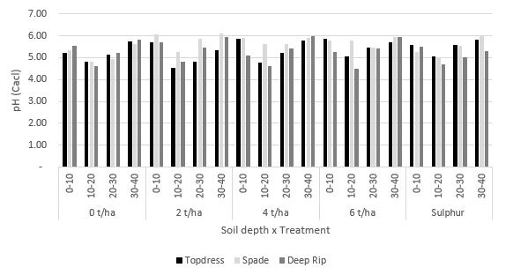
Figure 2: Soil pH 2020 measured across the soil profile specific to lime application rate and incorporation method
Multi-Year pH Analysis
Using the results from a multiyear (MET) analysis conducted using the ASReml-R package in R, it was observed that the incorporation treatment, Spading, was predicted to perform the best for all pH treatments and for all depths below 0-10cm (Figure 3). In terms of the actual results, it was found that, as expected, the highest lime application, (6 t/ha) in combination with spading resulted in the highest increase in pH. Notably though, for the soil depths 20-30cm and 30-40cm all lime application treatments performed nearly equally well, except for the control treatment (0 t/ha lime).
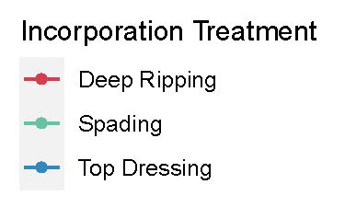
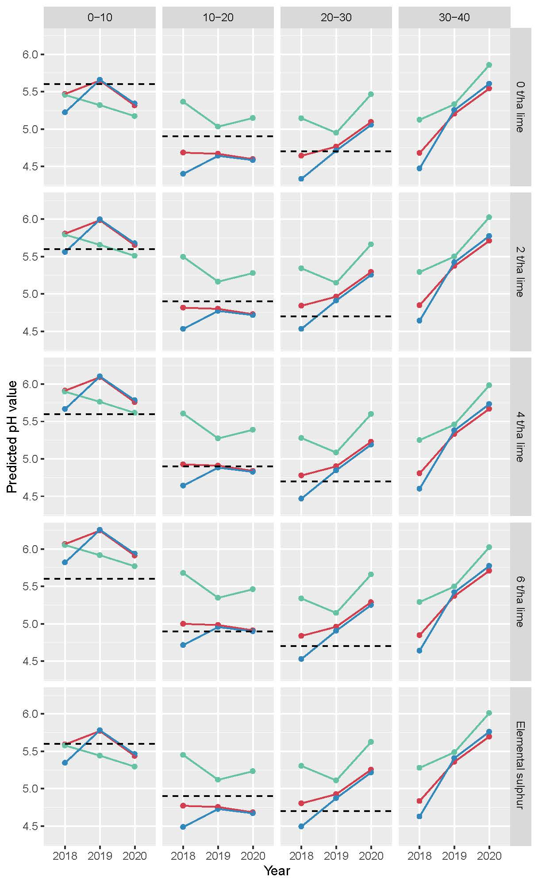
Figure 3 Predicted pH values over the 2018 to 2020 period using a multiyear MET analysis

Crop Establishment and Growth (NDVI):
Incorporation method and pH treatment did not significantly affect plant establishment (Figure 4). Crop establishment ranged from 124 plants per/sqm in the 0t/ha lime deep rip treatment, to 170 plants per/sqm for Top dressed lime at 4t/ha (Table 1). The recommended density for food barley crops is approximately 120-150 plants/sqm.
Table 1: Average plants per/sqm by pH treatment x incorporation method at Z23.
 | 0 t/ha | 2 t/ha | 4 t/ha | 6 t/ha | Sulphur
Incorporation - Top Dress | 155 | 158 | 170 | 152 | 139
Incorporation - Deep Rip | 124 | 155 | 129 | 156 | 128
Incorporation - Spading | 136 | 141 | 132 | 132 | 131

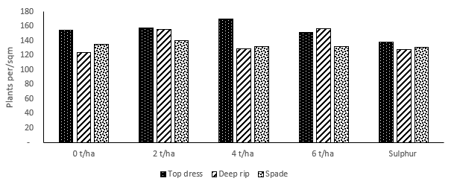
Figure 4 Average plants per/sqm by pH treatment and incorporation methods at crop growth stage Z23.

Crop growth measured as NDVI in Figure 5 indicates that Deep ripped lime application at all rates including a nil appliation produced slighty higher plant biomass. Top Dress and Spaded lime incorporation NDVI scores were not significanlty different at growth stage Z23.

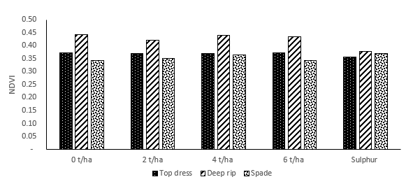
Figure 5 Average plant establishment measured as NDVI at Z23, across different lime application rates and incorporation methods

Harvest Yield
Harvest yield data was collected using a small plot header by SLR (Figure 6).
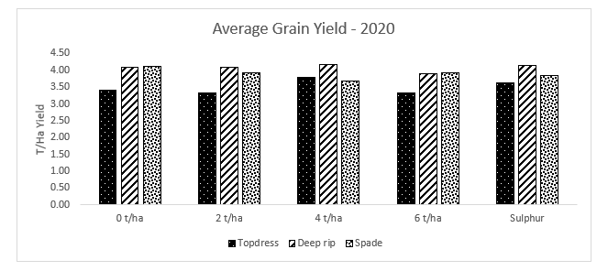
Figure 6: Harvest Yield Data for each lime application rate and incorporation method - 2020
The yield data for each treatment was analysed to determine any significant interactions. The effect of incorporation method on grain yield was found to be highly significant (p<0.001). Lime application rate, and the interaction between lime rate and incorporation method did not impact on grain yield. The deep rip treatment had the greatest impact on grain yield, followed closely by the spade treatment.
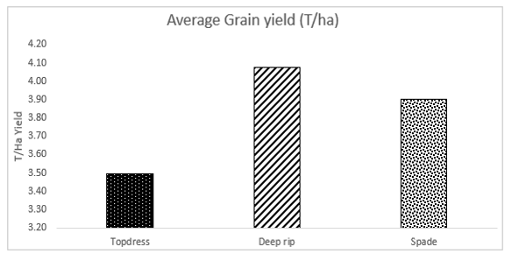
Figure 7: Average grain yield for each incorporation method - 2020
The average grain yield for each incorporation method is highlighted in Figure 7. Deep ripping had the highest average yield at 4.08t/ha, whereas topdressing resulted in the lowest average yield of 3.49t/ha. These results indicate an incorporation method boosts grain yield when compared to common practice of topdressing lime only.

Grain Quality
Grain protein and quality was assessed for each of the three replicates of each treatment, with the averages represented in Figure 8 and Table 2. Incorporation method and pH treatment did not significantly impact on grain protein, hectolitre weight or screenings. All treatments except the topdress with sulphur application met the protein requirements of MALT1 (9.5-12.8%). The highest average protein occurred in the spade with 4 t/ha lime treatment (10.8%), and this was also the treatment with the highest average screening percentage (60.27%).
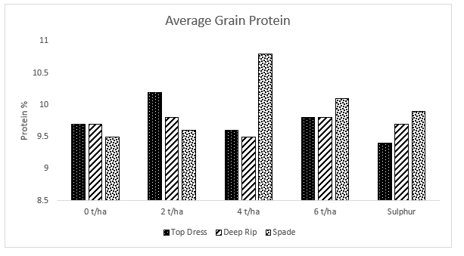
Figure 8: Average grain protein for each incorporation method and pH treatment.
Table 2: Average hectolitre weight and screenings for each treatment
pH treatment | Incorporation method | Hectolitre (g) | Hectolitre (%) | Screenings (%)
 | Top Dress | 335.73 | 67.15 | 27.86
0 t/ha | Deep Rip | 335.6 | 67.12 | 35.35
 | Spade | 341.27 | 68.25 | 34.32
 | Top Dress | 333.03 | 66.61 | 33.07
2 t/ha | Deep Rip | 339.03 | 67.81 | 35.24
 | Spade | 342.27 | 68.45 | 41.59
 | Top Dress | 339.07 | 67.81 | 22.81
4 t/ha | Deep Rip | 343.77 | 68.79 | 31.73
 | Spade | 334.83 | 66.97 | 60.27
 | Top Dress | 333.5 | 66.7 | 23.62
6 t/ha | Deep Rip | 336.2 | 67.24 | 34.54
 | Spade | 342.13 | 68.43 | 47.95
 | Top Dress | 331.99 | 66.4 | 22.24
Sulphur | Deep Rip | 303.63 | 67.99 | 38.41
 | Spade | 341.1 | 68.22 | 50.52

Economic Analysis
To calculate gross margins for the trial in 2020, a sale price of $275 for barley was assumed, with deductions for transport, storage, handling, fees, EPR, and levies making a price of $232.51/t at the farm gate. Initial treatment costs were carried forward from the 2019 calculations, and for calculating the 2020 gross margin these initial treatment costs were amortised over a 5 year time frame at a rate of 5%.
The highest yielding treatment was 4t/ha limesand and deep ripped. However, due to the variability in the site no significant differences emerged between the treatments.
Despite the variability across the sites, the treatment of 4t/ha limesand + deep ripping has delivered, on average, an additional $351/ha compared to the control site, after accounting for the treatment costs, over the two years of the project. Further, with no ameliorants applied, both spading and deep ripping have delivered almost $300/ha more than the control treatment (Table 3).
Table 3: Gross Margin ($/ha) for each pH treatment and incorporation rate.
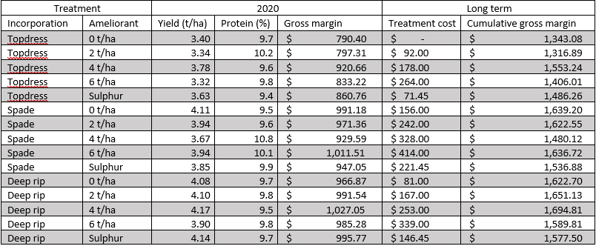

CONCLUSIONS
Observations have now been taken over three consecutive growing seasons to investigate the impact of pH treatment and incorporation rate on soil pH to depth.
The results from the statistical data analysis conducted by SAGI West using a single year model showed that the eﬀect of the pH treatment should weaken with time, with its aﬀect on the soil pH only being signiﬁcant in 2018. It also showed that there was no interaction between the pH treatment and the soil incorporation method.
The results of each season were combined in a MET analysis. This analysis showed that the best soil incorporation technique for increasing the soil pH was spading, which was true for all depths below 0-10cm. Although the highest application of lime (6t/ha) had the best results, at depths between 20-30cm and 30-40 cm, all treatments performed equally well, except for the control treatment (0 t/ha). From 2018 to 2020 an upward trend (increasing soil pH) was observed at the depths 20-30cm and 30-40cm, for all soil incorporation and pH treatments. However, the eﬀect on a year by year basis for the top and subsoil (0-10cm and 10-20cm) from the soil incorporation and pH treatments did not show a definable trend, with the pH in 2020 being slightly lower or higher than the pH in 2018.
The 2020 trial indicated that grain yield can be influenced by incorporation method, however no effect on yield due to lime application rate was observed. Therefore, to increase grain yield producers should factor incorporation method into management decisions to boost productivity. Lime application rate was impactful on pH in the year of application, but did not correlate into an increased grain yield for subsequent crops. The pH levels of the soil may not have been acidic enough to impact on grain yield in this trial, hence the lack of response to lime application rate in grain yield.
Gross margins conducted by Planfarm determined the highest economic benefit was found in the 4t/ha lime sand + deep ripping treatment, which increased returns of $351/ha compared to the control site. Additionally, with no ameliorants applied, both spading and deep ripping have delivered almost $300/ha more than the control treatment.

Extension
Extension activities have been undertaken as per the Communication and Extension Plan. One newsletter article to extend on trial purpose and results has been sent to all Facey Group members each year. The bi-monthly Facey Group newsletter is distributed to all members (currently 90+ farming entities which incorporates over 300 individuals) as well as sponsors and various local industry.
A trial report summary was included in the annual Spring Field Day booklet that was distributed to all attendees. Approximately 90 growers attended the 2020 Spring Field Day event, along with various industry representatives and sponsors. A trial report and economic analysis was presented at the Facey Group Trial Presentation event. The detailed collaboration of results was also included in the annual Trials & Demonstrations Results booklet which is distributed to all members and attendees.
SOCIAL MEDIA POSTING
DISCLAIMER This report has been prepared in good faith on the basis of information available at the date of writing without any independent verification. The Grains Research and Development Corporation does not guarantee or warrant the accuracy, reliability, completeness of currency of the information in this report nor its usefulness in achieving any purpose. Readers are responsible for assessing the relevance and accuracy of the content of this report. The Grains Research and Development Corporation will not be liable for any loss, damage, cost or expense incurred or arising by reason of any person using or relying on the information in this report. Products may be identified by proprietary or trade names to help readers identify particular types of products but this is not, and is not intended to be, an endorsement or recommendation of any product or manufacturer referred to. Other products may perform as well or better than those specifically referred to.
GRDC uses social media to showcase research investments and disseminate timely, relevant and practical information to key stakeholders in the grains industry. Our audiences are predominantly growers and agricultural advisers.
SOCIAL MEDIA ACCOUNTS:
Facebook: https://www.facebook.com/theGRDC
Twitter: https://twitter.com/theGRDC
YouTube: http://www.youtube.com/user/theGRDC
LinkedIn: http://www.linkedin.com/company/thegrdc

Is there any reason why this report cannot be communicated on social media? (Insert info here)

If no, please provide the following:
- Who is the target audience for this content? (e.g, growers, adviser, researchers, policy makers, etc.)
The results from this trial target all growers in the WA wheatbelt who have duplex soils, with the key outcomes/results made publicly available and extended out to the greater agricultural sector for the benefit of the entire grains industry.
Key findings have been presented to Facey Group members, and will also be publicly available on the Facey Group website, released through various forms of media and will be presented at events hosted by the Facey Group that are open to the public.

- At what time of year is this content most relevant to the target audience?
Between harvest and pre-seeding, when producers are likely to be applying lime and performing other soil amelioration work.

- On which of GRDC’s social media accounts would you like this content posted? Please provide text (2-3 sentences for Facebook and LinkedIn and 140 characters for Twitter), images, graphs, or charts that support the content. Where applicable, please include any relevant Twitter handles (usernames) for project staff.
Any available social media accounts would be acceptable for this content to be posted.
Facebook page – Facey Group
Twitter - @FaceyGroup
‘The fourth season of GRDC and Facey Group’s lime incorporation trial is underway, investigating the cost benefit of combining lime application with tillage on soil pH, crop emergence and grain yield.

PROJECT SOCIAL MEDIA ACCOUNTS
Facey Group Facebook: https://www.facebook.com/FaceyGroup6370
Twitter: https://twitter.com/FaceyGroup
Published in Facey Group newsletter – Edition 2, April 2020
https://mcusercontent.com/542256b4f9e6fdd611456c10c/files/b08d75ea-57c5-41e4-af7a-f28199f56ee4/2019_Lime_Incorporation_trial_Facey_Group_report.pdf

REFERENCES & USEFUL LINKS
List of key publication references and web links relevant to the project and for further exploration of the topic.
https://researchlibrary.agric.wa.gov.au/bulletins/223/
https://grdc.com.au/news-and-media/news-and-media-releases/west/2014/03/cultivation-can-pay-off-for-lime-incorporation

